 

Assignment - 2

|  |  |
| --- | --- |
| **Student Name/ID Number:** | Wildan Luqmanul Hakim |
| **Unit Number and Title:** | Database Design & Implementation |
| **Academic Year:** | 2022 |
| **Unit Assessor:** | Arvinder Kaur |
| **Project Title:** | Implementing a Database for Community Portal |
| **Issue Date:** | 27 July 2022 |
| **Submission Date:** | 30 July 2022 |
| **Internal Verifier Name:** |  |
| **Date:** | 30 July 2022 |

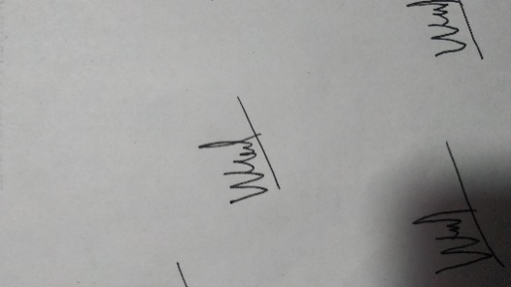

30 July 2022

Date:

Student signature:

I certify that the work submitted for this assignment is my own and research sources are fully acknowledged.

**Learner declaration**

|  |
| --- |
| **Purpose of this project** |
| **Purpose of this project**  To demonstrate your capabilities in the following areas:   * Ability to Implement a MySQL Database based on design created in Mini Project 1 |
| **Submission Format** |
| 1. Screen capture of Database Table structure in PhpMyAdmin 2. Queries used by Web pages in Tabular Format |
| **Project Brief & Guidance** |
| **Scenario:**  **Refer to the Project Scenario for the Module Project**  You have been approached by ‘ABC Jobs Pte Ltd’ as a website developer to develop a community portal for Software Developers. The project will be carried over through Module 3, Module 4, Module 5 and Capstone project. For this module the scope is to Design, Develop, Implement & Document Struts Framework Website.  The Scope of the Project is to design a Community Portal Similar to Linkedin.com. Users will be able to register in the portal using the Registration Page. Users of the portal can search for other users using various parameters such as First Name, Last Name, Company Name, City & Country. Users will be able to view the Public Profile of users after searching them. The portal allow users to login, request for forgotten password and Update their profile information  The scope of the mini project is to implement the database in MySQL.  **The overview of the project is as below**  There are 2 types of users in this Community portal. They are   1. Software Programmer 2. Administrator   **Software Programmer should be able to perform following functions in the portal**   1. Allow the programmers to register in the portal, show a thank you page & send a registration confirmation email. 2. Search & Find Other Programmers after login and view their profile. 3. Provide Login Page 4. Provide password retrieval functionality. |

|  |
| --- |
| 1. Update their Profile after logging in.   Following Functionality is part of Database Design & Will be enhanced as features as required in the Capstone Project, Depending on time availability.   1. Send Messages to Each Other on the Portal 2. Create Threads & Post Replies to a Thread 3. Post Job Opportunities in the Portal   **Administrator should be able to perform following functions in the portal**   1. Administer user data. 2. Send bulk email inviting programmers to register on the community portal   **The portal consist of the following Key pages (For Reference)**   1. Community Portal Home Page 2. Registration Page 3. Registration Confirmation Page 4. Update Profile Page 5. Search Users Page 6. List Search Results 7. Public Profile Page 8. Registration Confirmation Email 9. Login Page 10. Forget Password Page 11. Design the Forget Password Confirmation Page   Following Functionality is part of Database Design and will not be part of development & Will be enhanced as features are required in the Capstone Project, Depending on time availability.   1. Send Messages 2. Read Messages 3. Post in Message Board 4. List Message Board 5. Read A Thread 6. Post Job Opportunities 7. List Job Opportunities & Responses   **The scope of this assignment**  The scope is to Implement the database in MySQL   * 1. Create the tables based on design in Mini Project 1   2. Take note of Field Name, Field Type & Size   3. Implement the database in MySQL and provide screen capture   4. Create a user name in MySQL which can be used by the application, give required access privileges. (Provide screen capture of the user with access privileges)   e. Briefly list the web pages in the Community portal and queries which will be used by each of them. |

1. Create the tables based on design in Mini Project 1

|  |  |
| --- | --- |
| Entity Name | Table Name |
| User | db_user  user_id (PK)  first_name  last_name  company  city  country  email  password |
| User Profile | db_user_profile  user_id (UNIQUE)  status_id (PK)  username  job_status  experience  company  bio |
| Admin | db_admin  admin_id (PK)  first_name  last_name  email  password |
| Job | db_job  job_id (PK)  company_name  job_desc  job_type |
| Company | db_company  company_id (PK)  company_name  company_address |
| Thread | db_thread  thread_id (PK)  date  time  thread_desc  comment |
| Messages | db_message  message_id (PK)  date  time  message  to  from |

1. Take note of Field Name, Field Type & Size

|  |  |
| --- | --- |
| Entity Name | Table Name |
| User | tb_user   |  |  |  | | --- | --- | --- | | Field Name | Field Type | Size | | user_id | int | 11 | | first_name | varchar | 48 | | last_name | varchar | 48 | | company | varchar | 48 | | city | varchar | 48 | | country | varchar | 48 | | email | varchar | 64 | | password | varchar | 32 | |
| User Profile | tb_user_profile   |  |  |  | | --- | --- | --- | | Field Name | Field Type | Size | | user_id | int | 11 | | status_id | int | 11 | | username | varchar | 16 | | job_status | varchar | 24 | | experience | varchar | 24 | | company | varchar | 48 | | bio | varchar | 500 | |
| Admin | tb_admin   |  |  |  | | --- | --- | --- | | Field Name | Field Type | Size | | admin_id | int | 11 | | first_name | varchar | 48 | | last_name | varchar | 48 | | email | varchar | 64 | | password | varchar | 32 | |
| Job | tb_job   |  |  |  | | --- | --- | --- | | Field Name | Field Type | Size | | job_id | int | 11 | | company_name | varchar | 24 | | job_desc | varchar | 500 | | job_type | varchar | 10 | |
| Company | tb_company   |  |  |  | | --- | --- | --- | | Field Name | Field Type | Size | | company_id | int | 11 | | company_name | varchar | 24 | | company_address | varchar | 255 | |
| Thread | tb_thread   |  |  |  | | --- | --- | --- | | Field Name | Field Type | Size | | thread_id | int | 11 | | date | date |  | | time | varchar | 8 | | thread_desc | varchar | 500 | | comment | varchar | 255 | |
| Messages | tb_messages   |  |  |  | | --- | --- | --- | | Field Name | Field Type | Size | | message_id | int | 11 | | date | date |  | | time | varchar | 8 | | message | varchar | 255 | | to | varchar | 48 | | from | varchar | 48 | |

1. Implement the database in MySQL and provide screen capture

**Creating DATABASE**

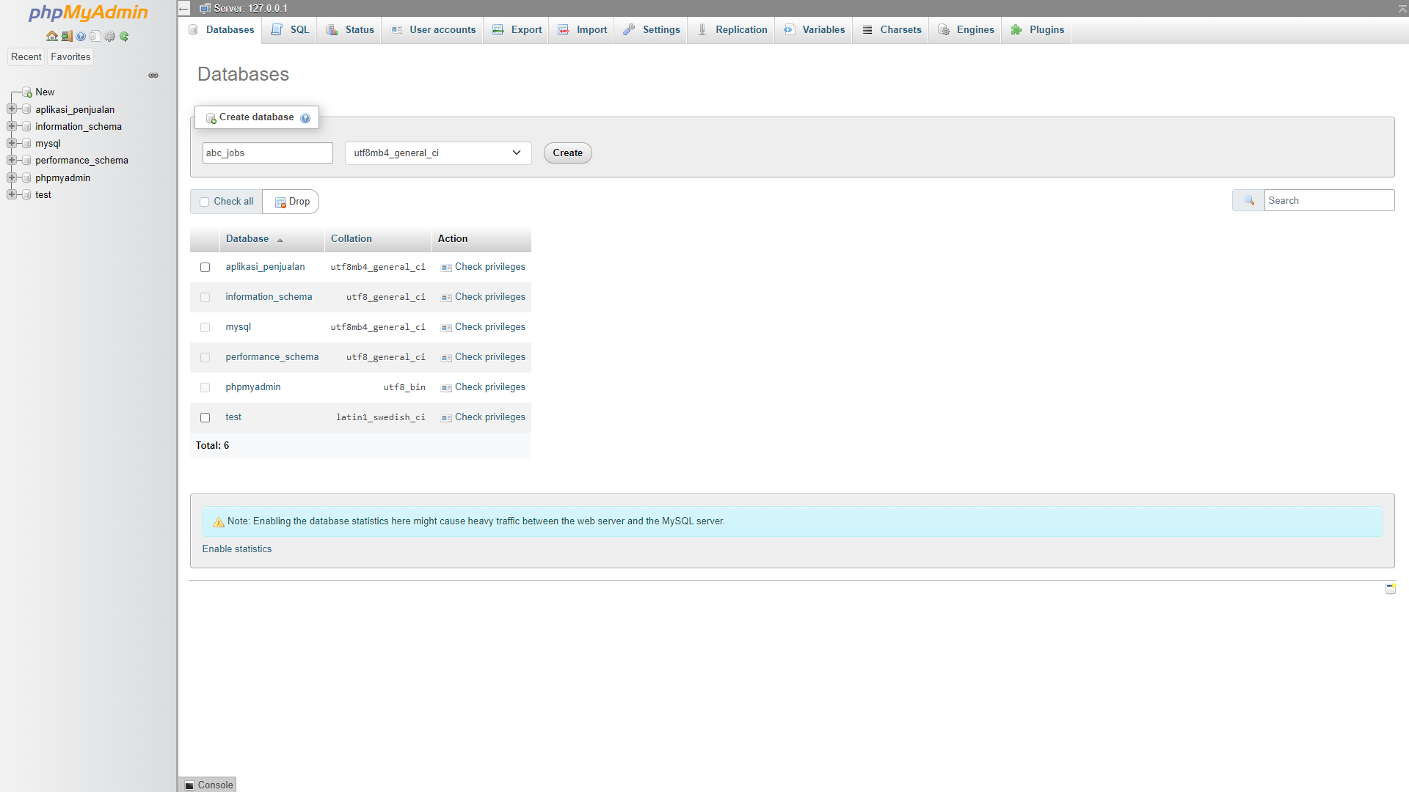

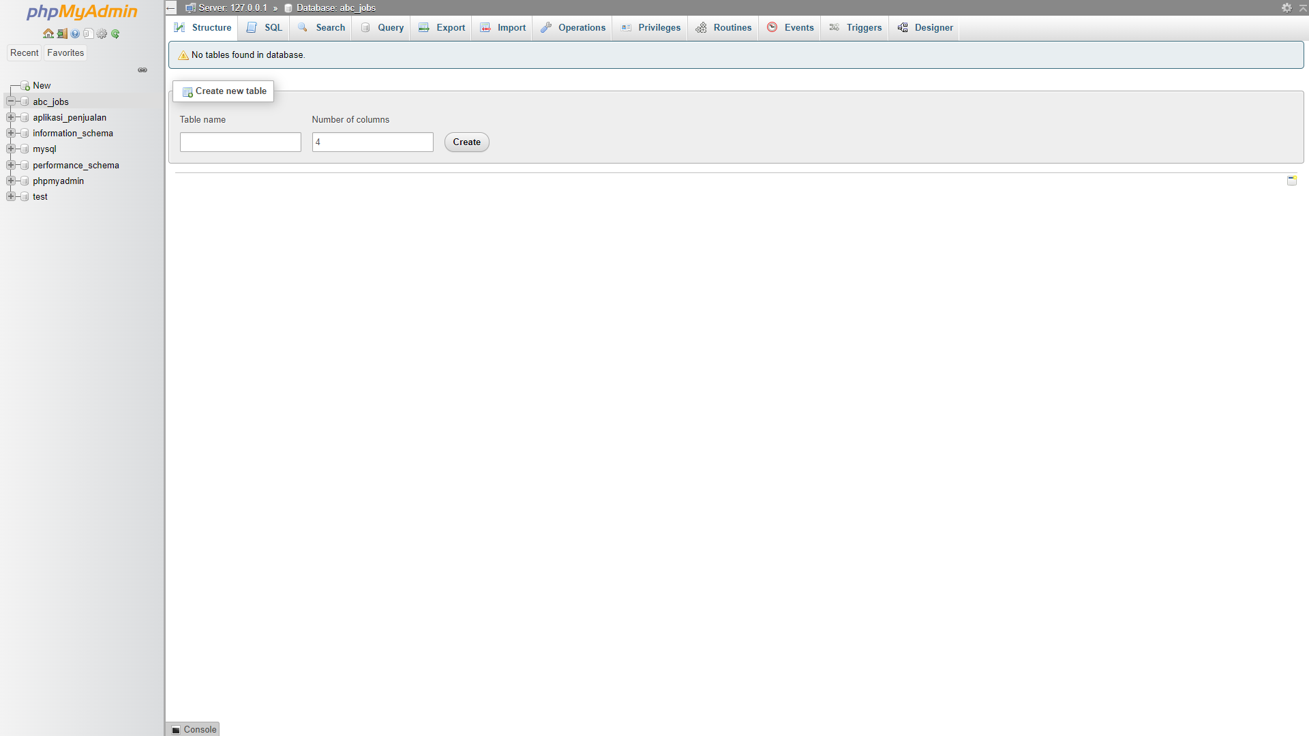

Creating Table

1. Creating user table

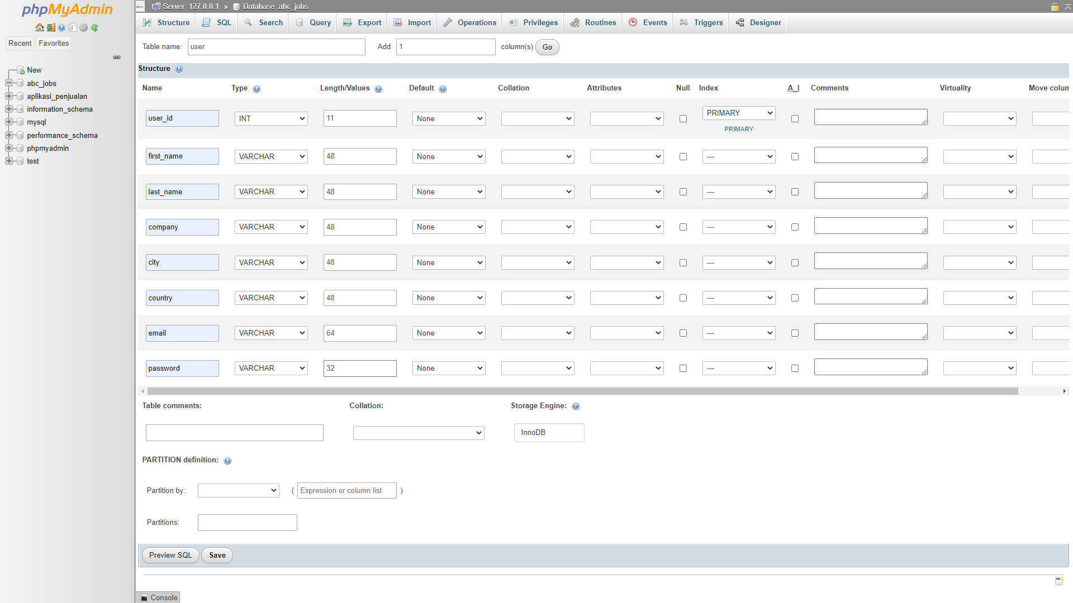

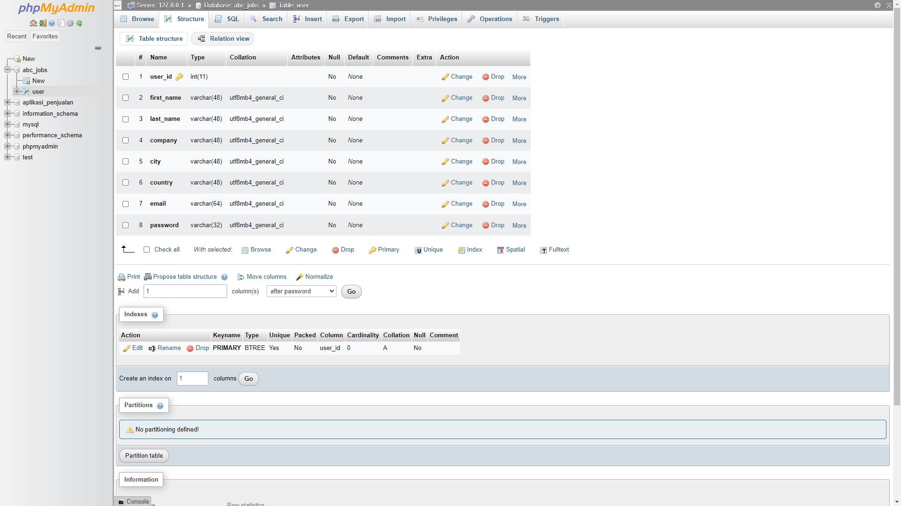

1. Creating user profile table

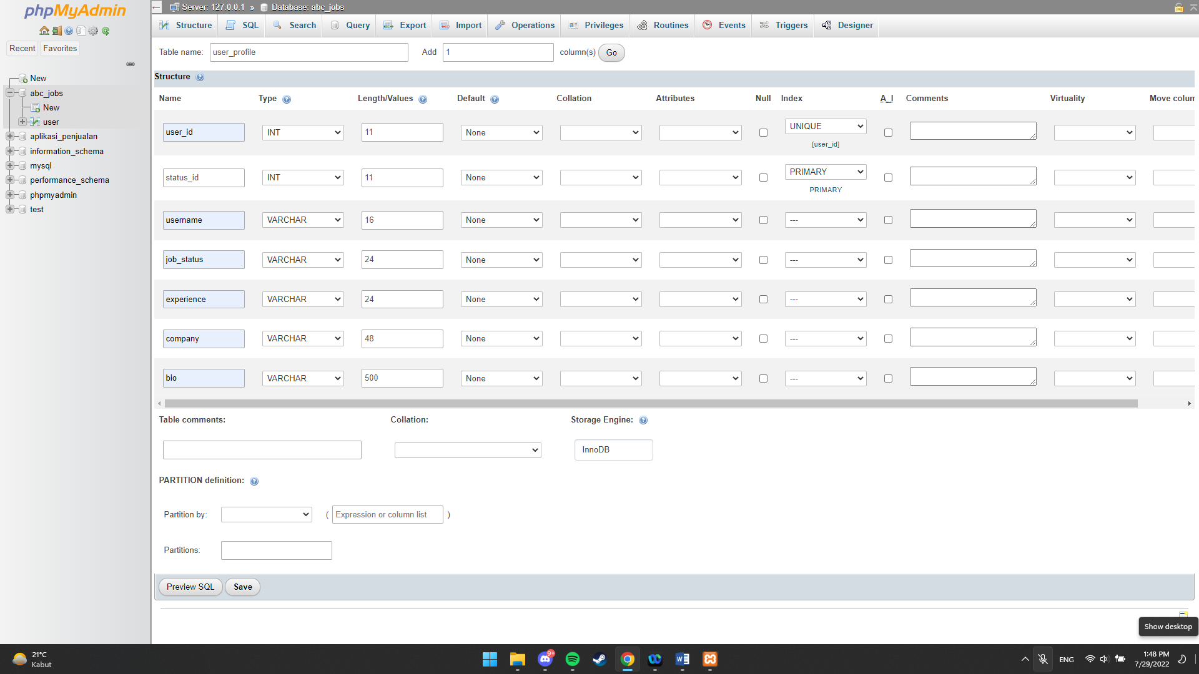

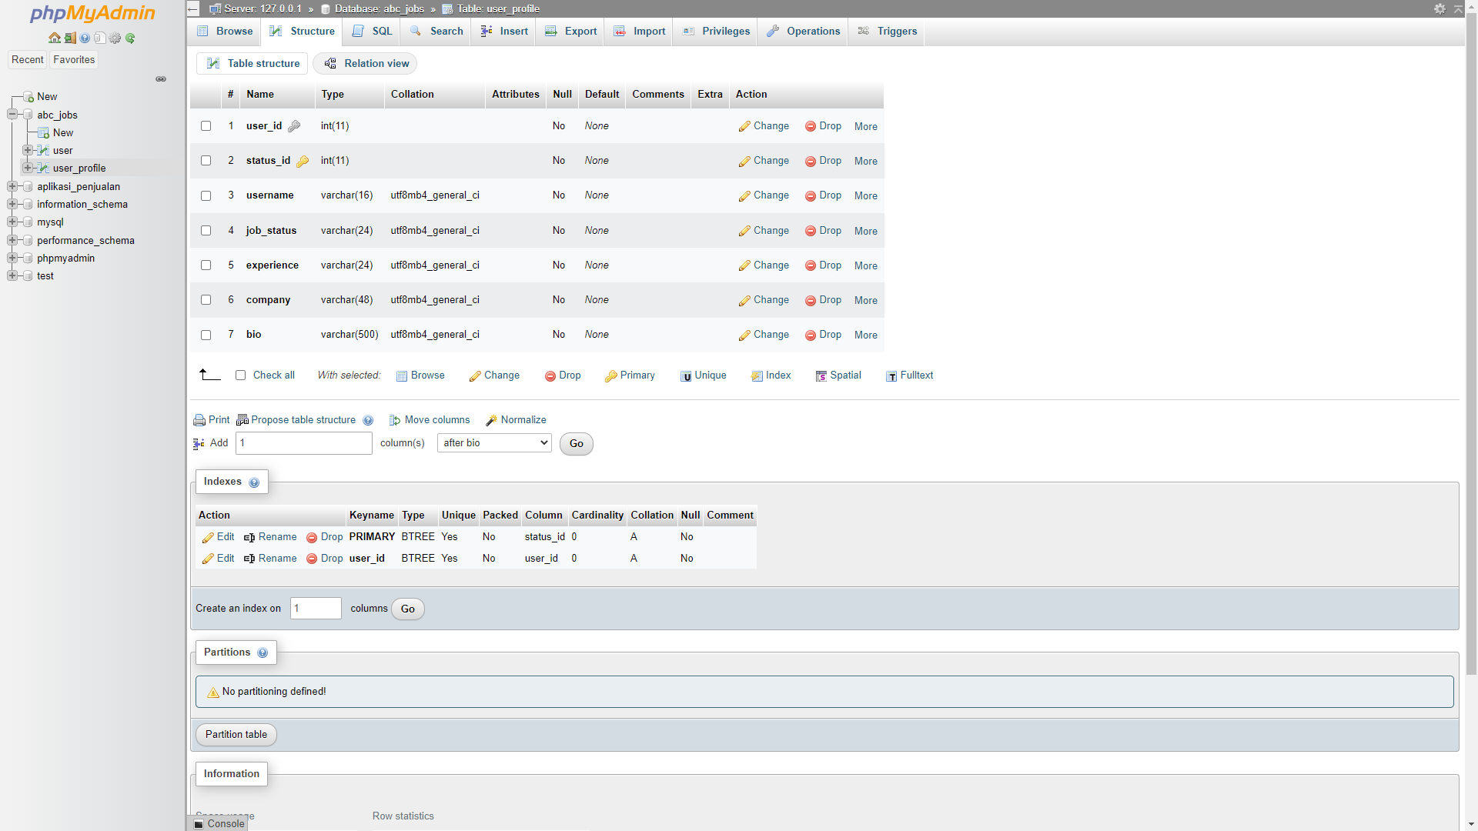

1. Creating admin table

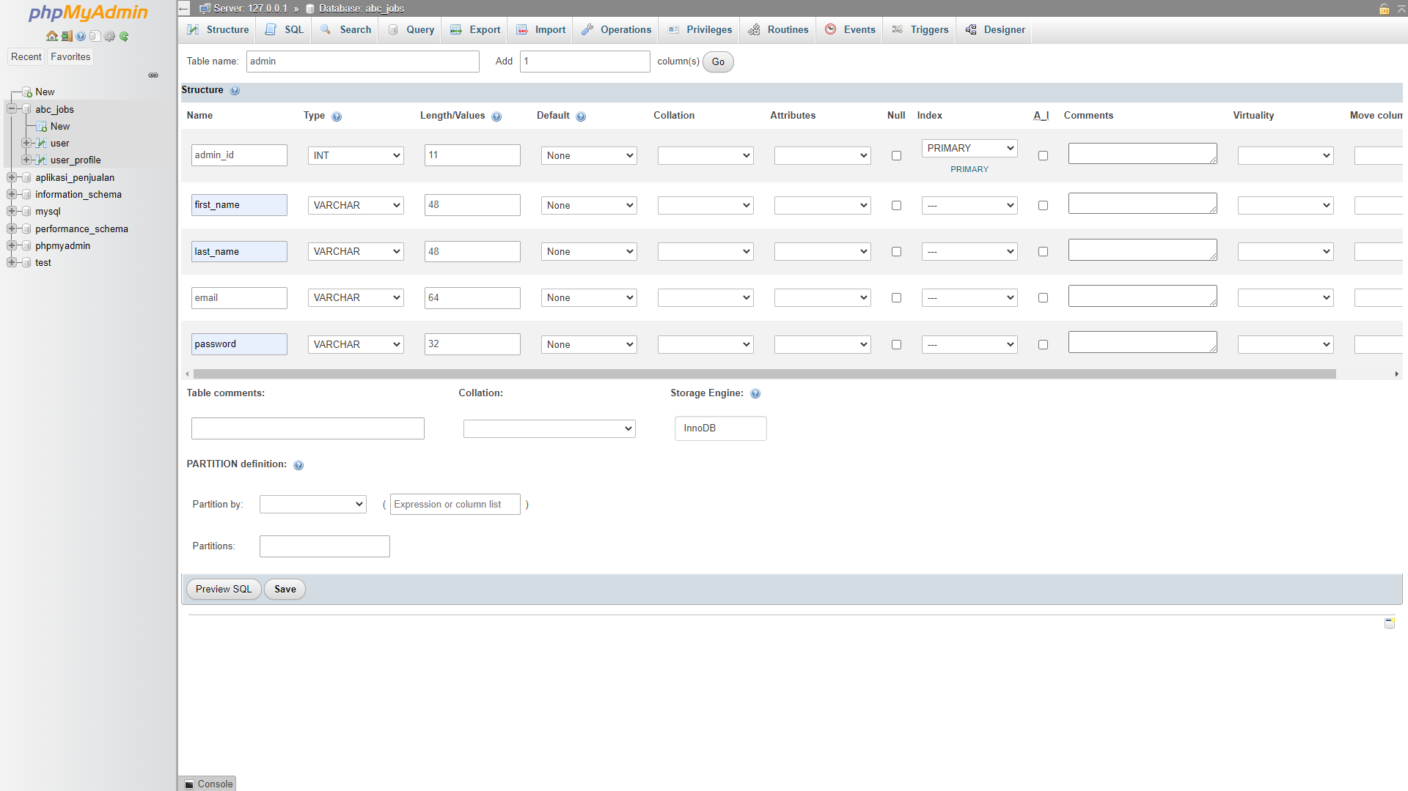

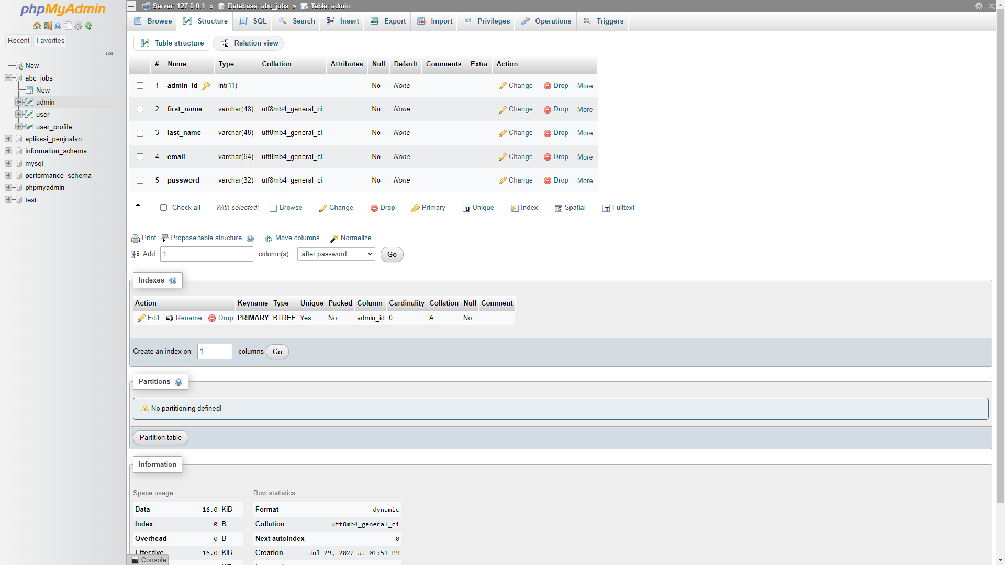

1. Creating job table

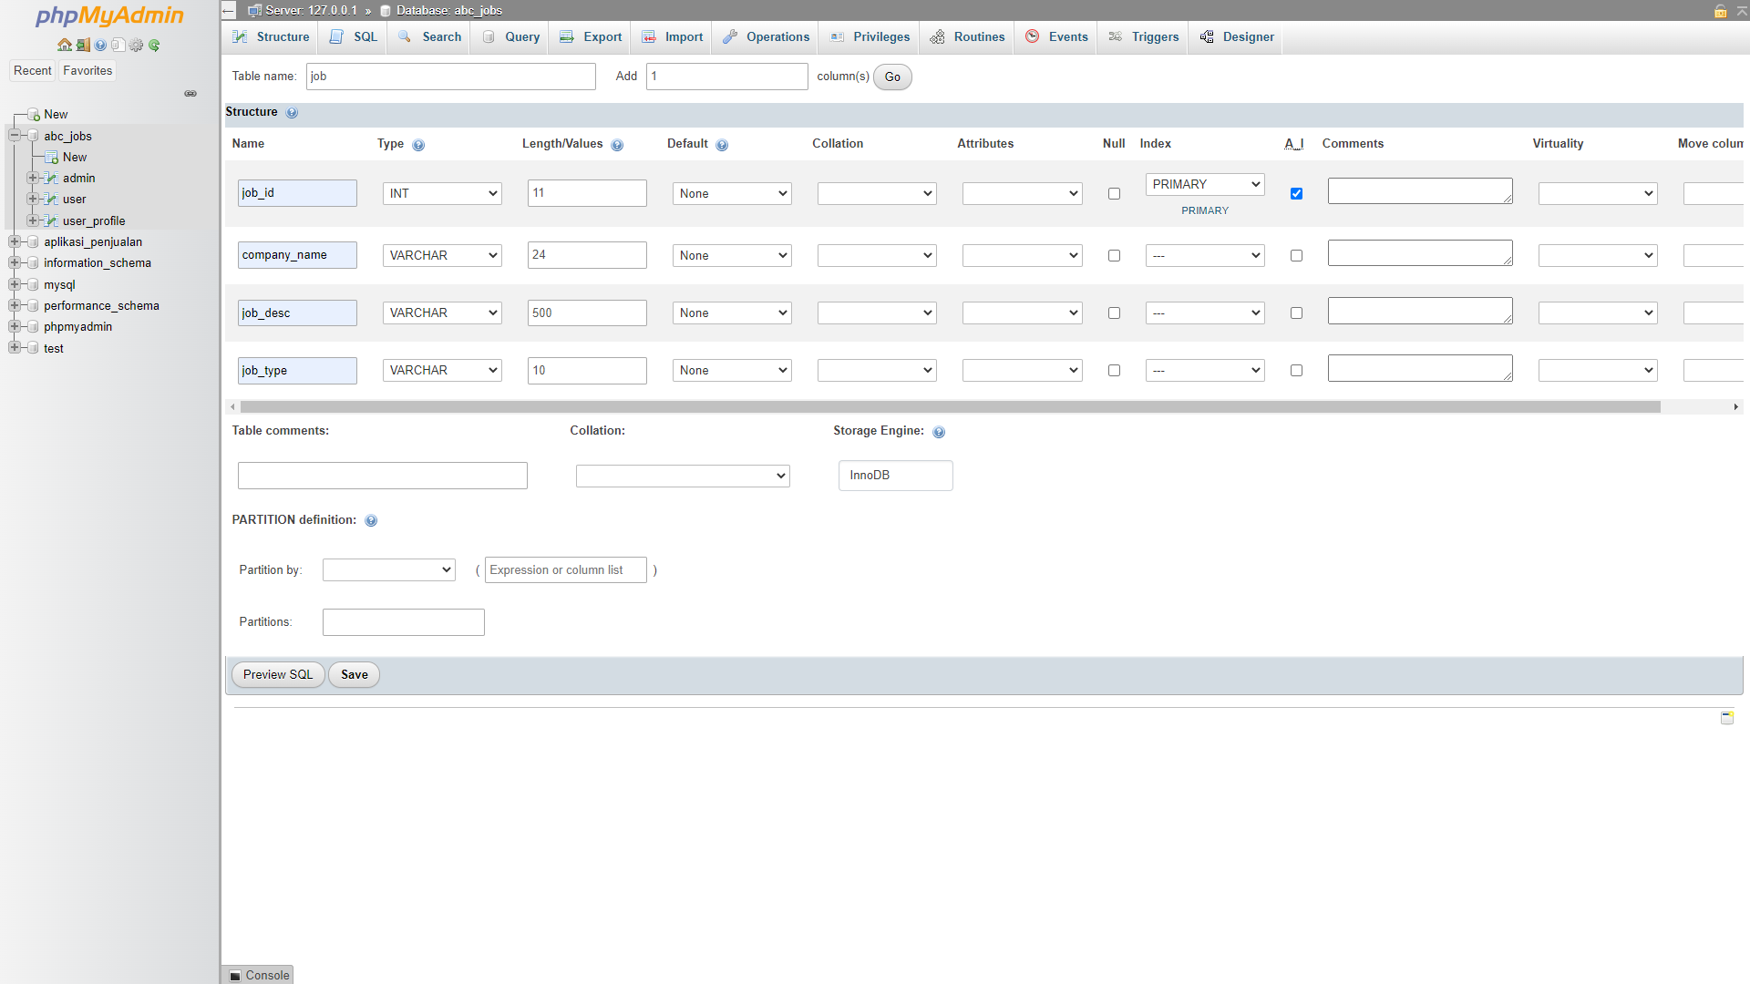

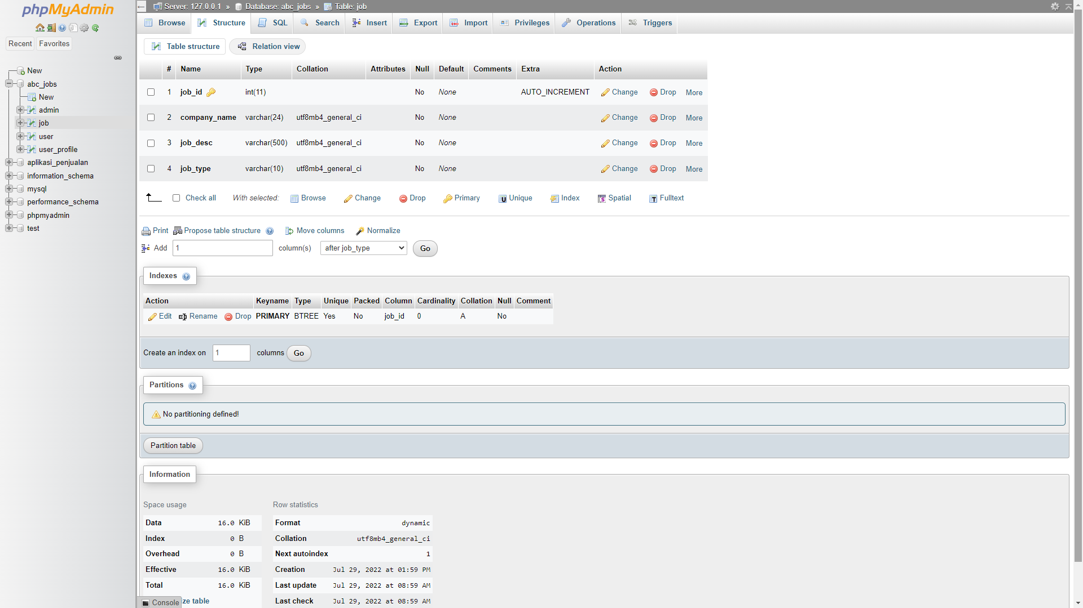

1. Creating company table

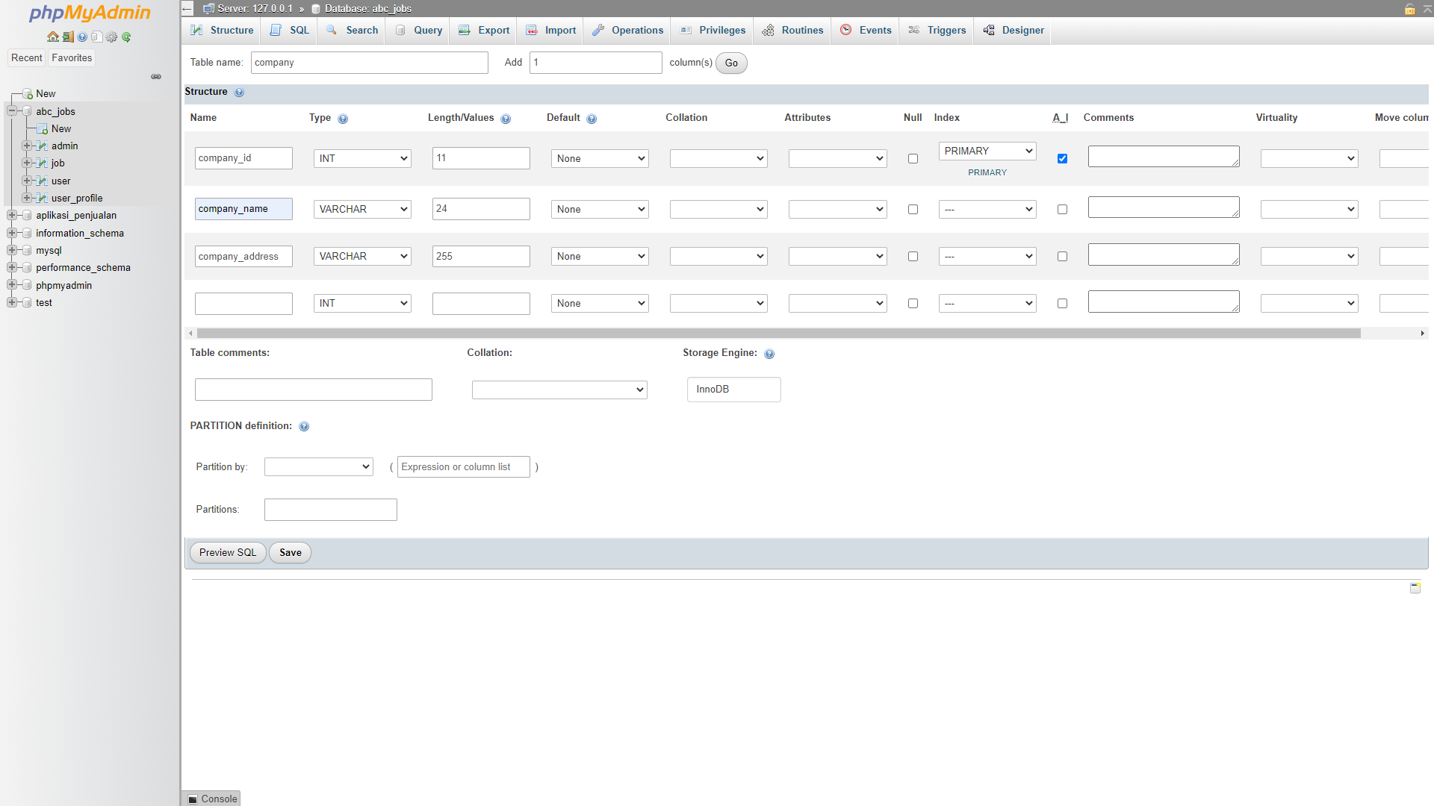

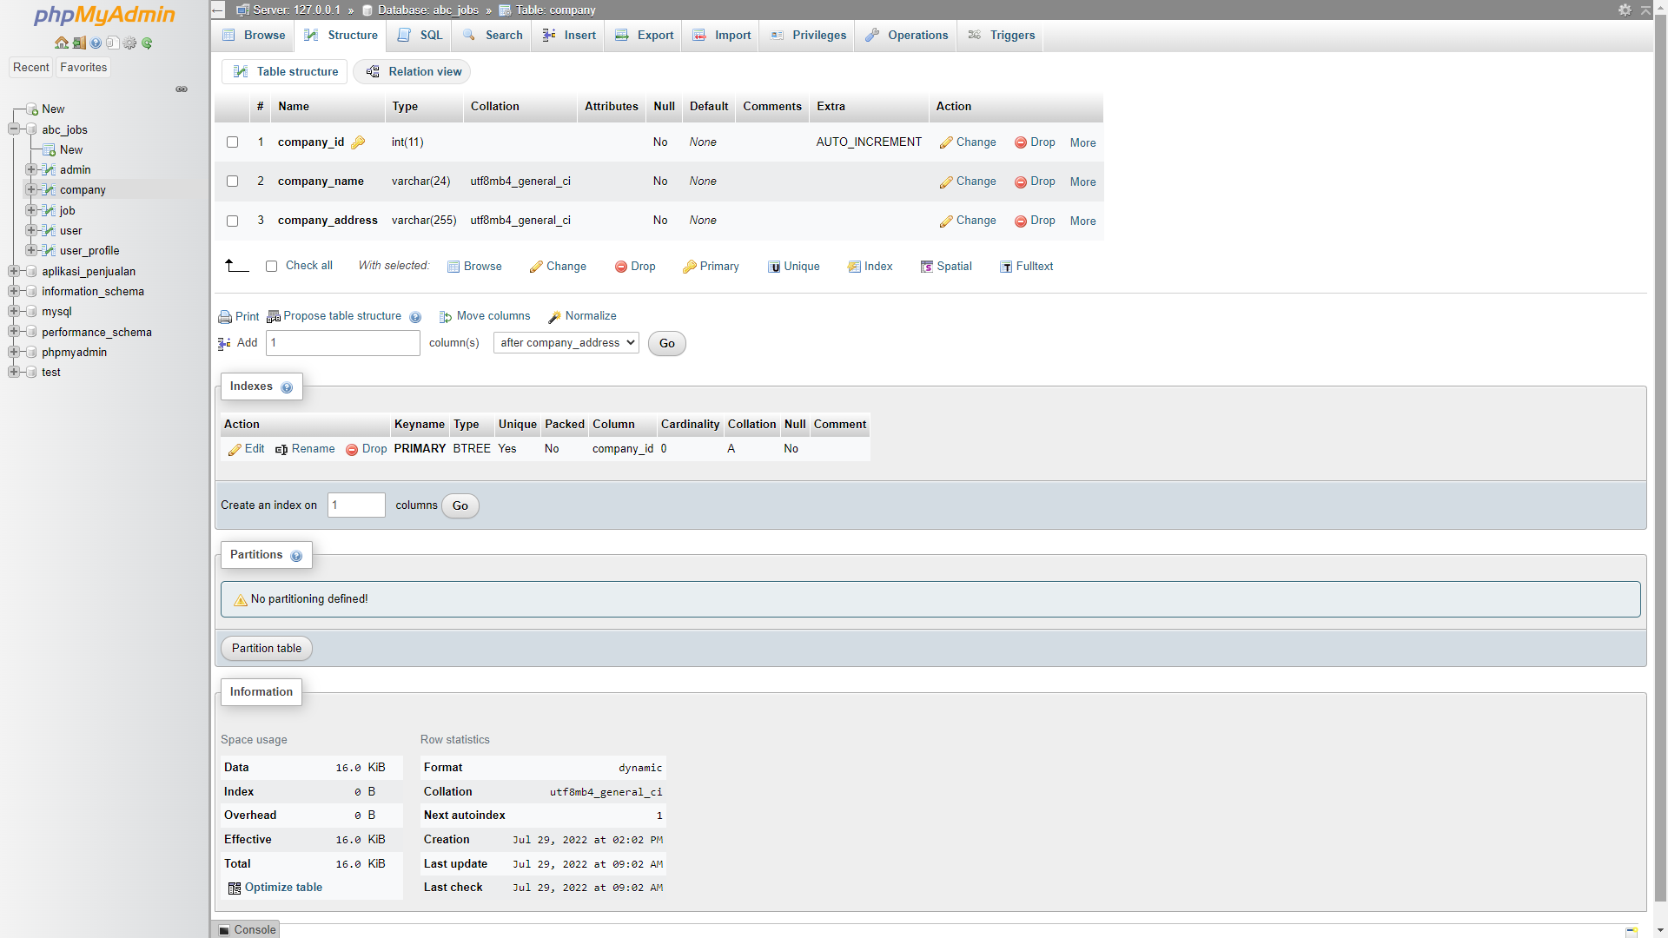

1. Creating thread table

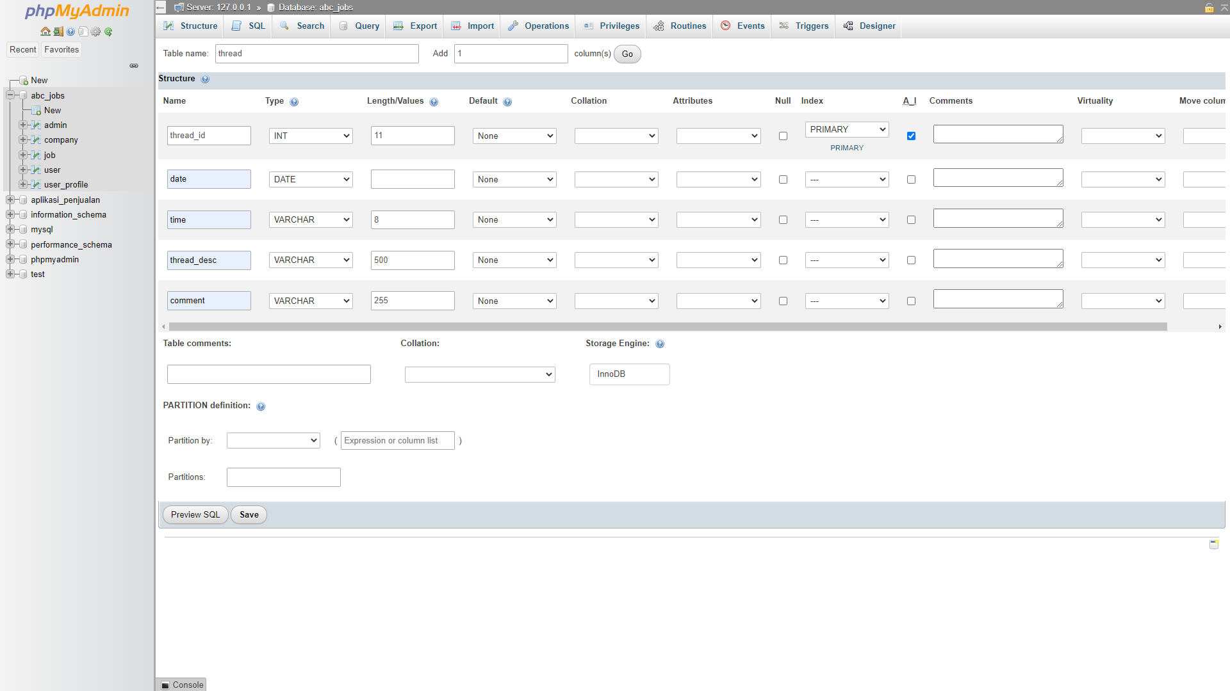

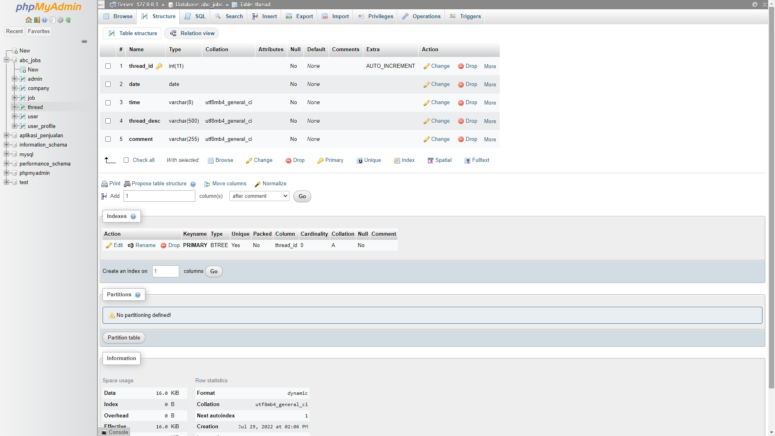

1. Creating message table

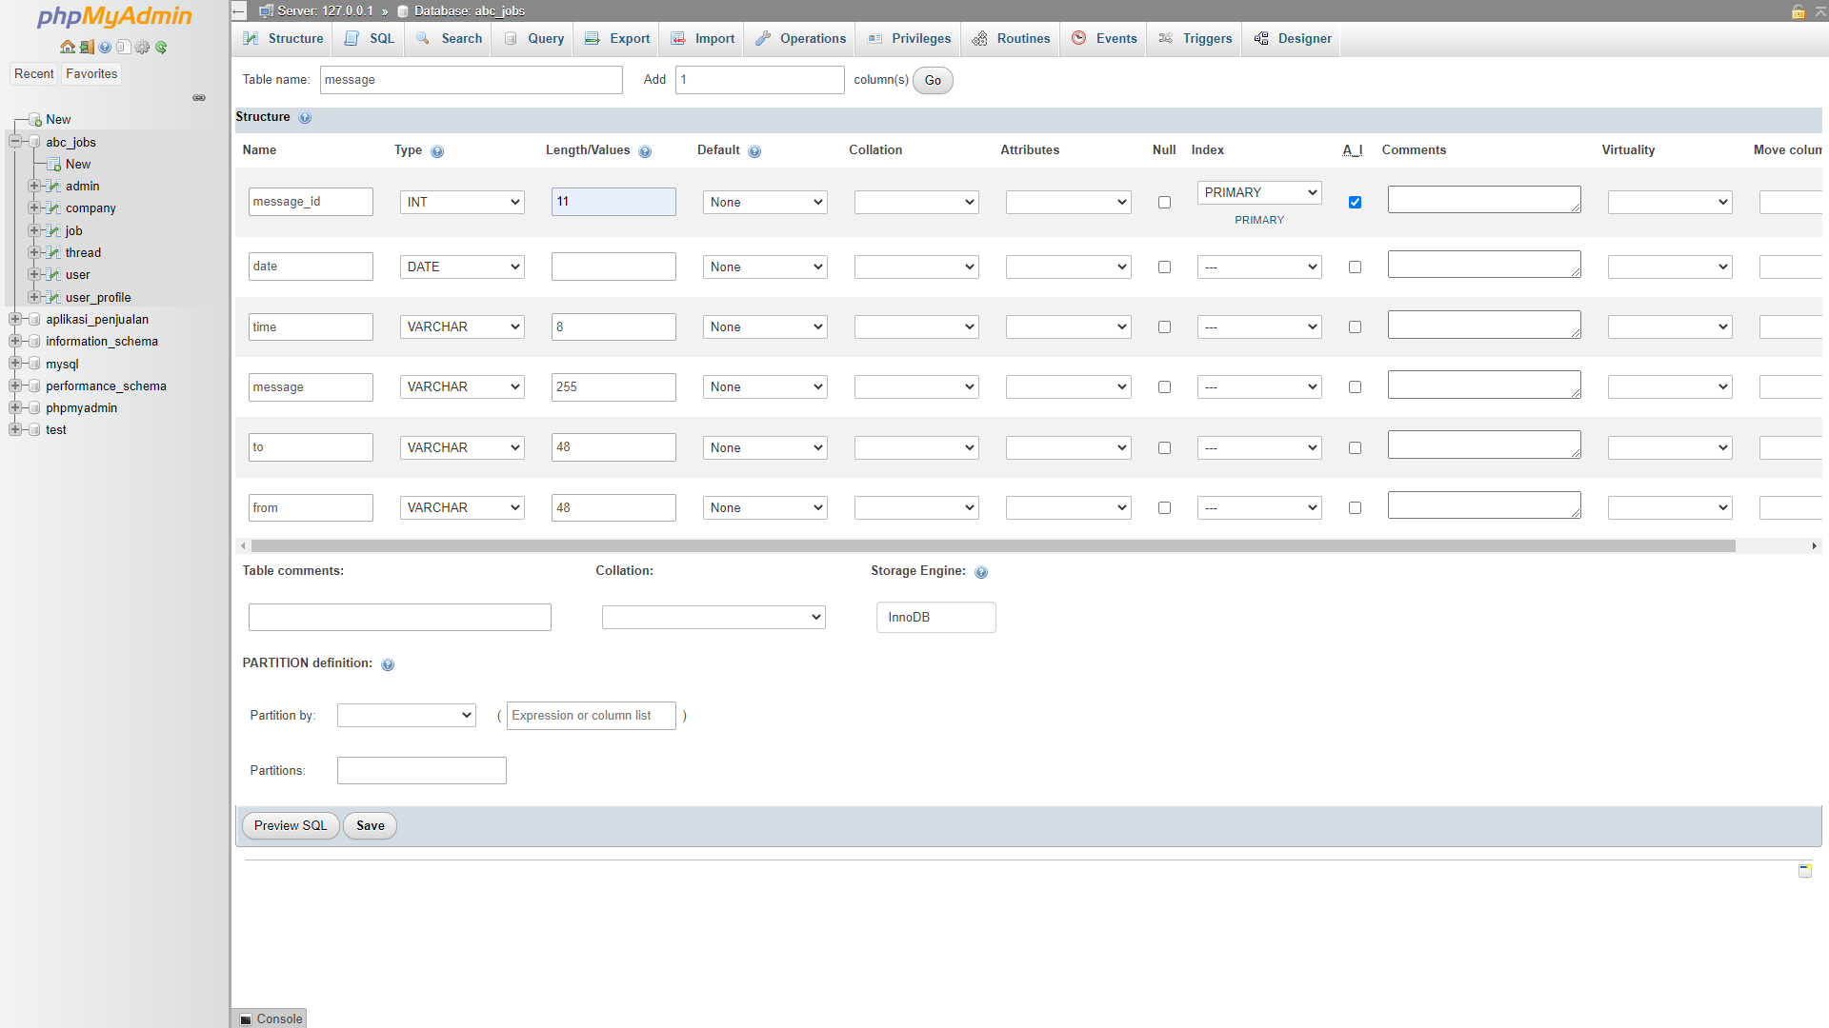

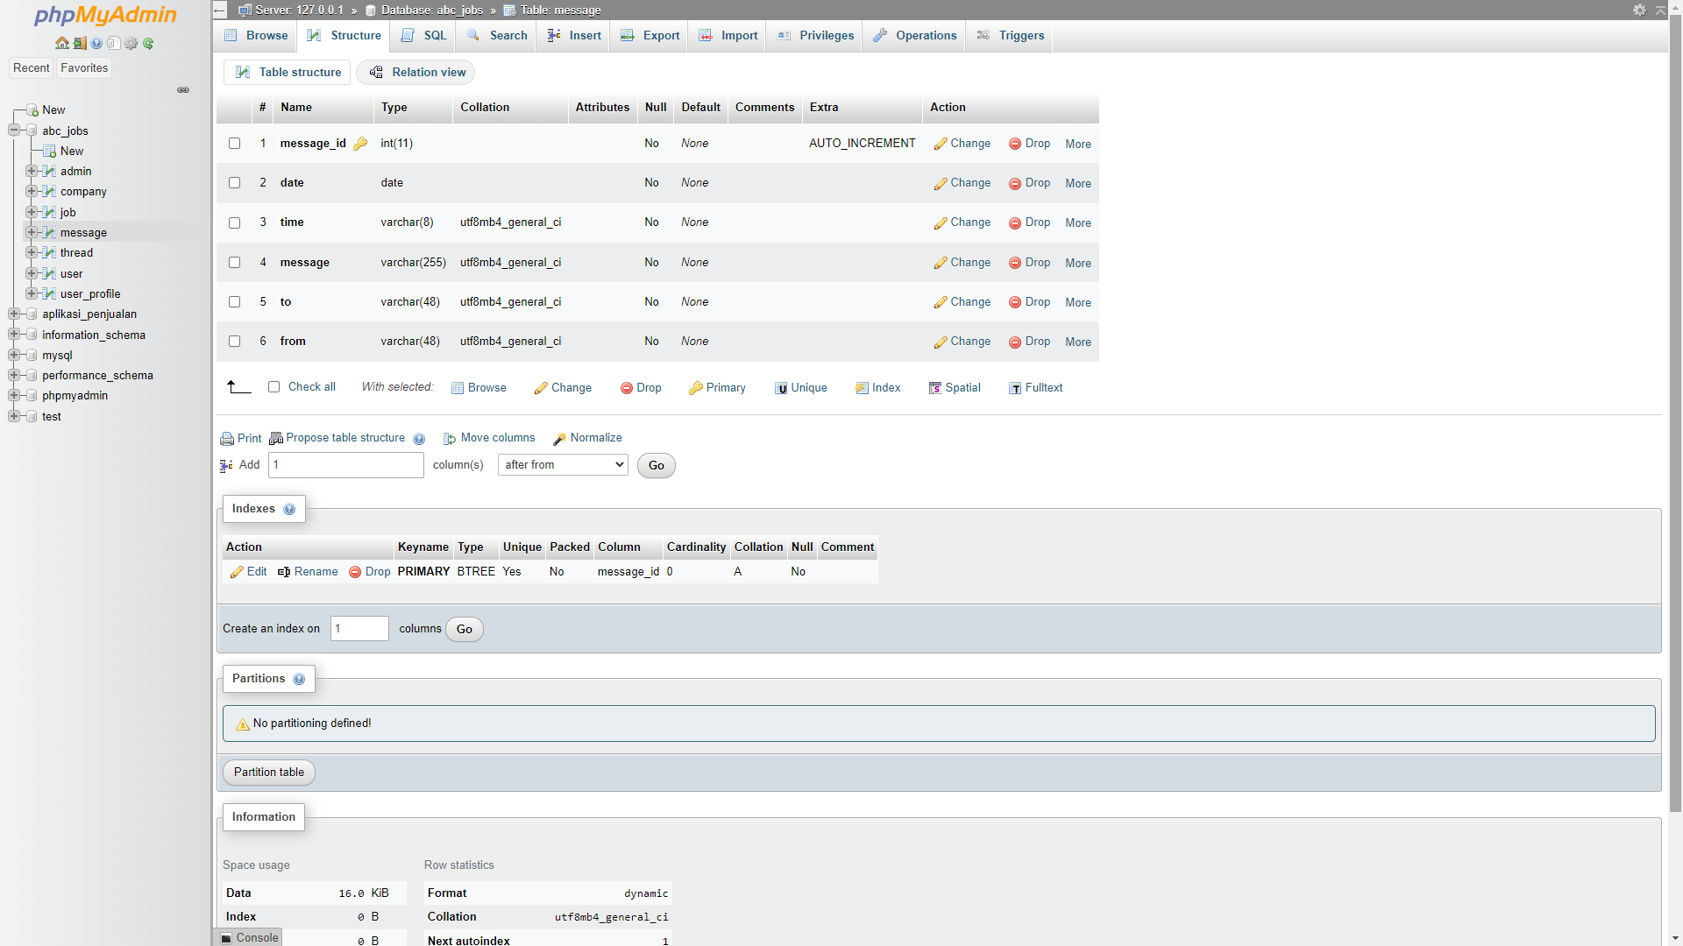

1. Create a user name in MySQL which can be used by the application, give required access privileges. (Provide screen capture of the user with access privileges)

CREATE USER 'root2'@'localhost' IDENTIFIED BY '123456';

GRANT ALL PRIVILEGES ON bdse04 . * TO 'root2'@'localhost';

FLUSH PRIVILEGES;

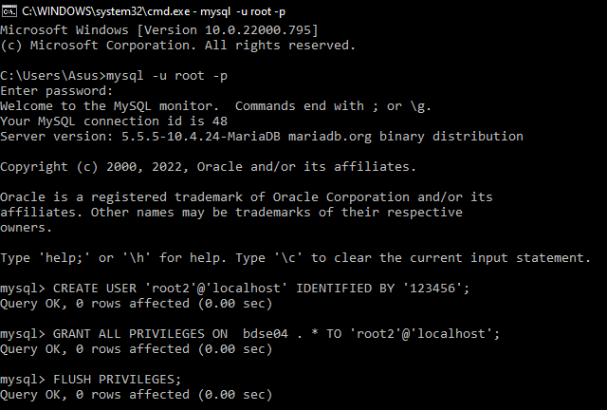

1. Briefly list the web pages in the Community portal and queries which will be used by each of them.

|  |  |  |
| --- | --- | --- |
| No | Page Name | Query |
| 1 | Registration Page | INSERT INTO user  VALUES (1, 'Wildan', 'Luqmanul Hakim', 'Google', 'Sumedang', 'Indonesia', 'wildanluqmanul@gmai.com', 'password123'); |
| 2 | Login Page | SELECT * FROM user  WHERE email=’wildanluqmanul@gmail.com’ and password=’password123’; |
| 3 | Search Page | SELECT * FROM user  WHERE first_name LIKE 'searchField' OR last_name LIKE ‘searchField’ OR company LIKE ‘searchField’ OR city LIKE ‘searchField’ OR country LIKE ‘searchField’; |
| 4 | Profile Edit Page | UPDATE user  SET company = ‘Intel’, city = ‘Bandung’  WHERE user_id = 1; |
| 5 | Post Thread Page | INSERT INTO thread  VALUES (1, ‘28 July 2022’, ‘11:06 PM’, ‘Good Morning’, ‘Morning’); |
| 6 | Send Message Page | INSERT INTO message  VALUES (1, ‘29 July 2022’, ‘09:55 AM’, ‘Hello there’, ‘Barry Portillo’, ‘Wildan Luqmanul Hakim’); |
| 7 | Read Message Page | SELECT * FROM message; |
| 8 | Forgot Password Page | SELECT * FROM user  WHERE email=’wildanluqmanul@gmail.com’; |
| 9 | Read Thread Page | SELECT * FROM thread; |
| 10 | Post Job | INSERT INTO job  VALUES (1, ‘Google’, ‘We Are Looking For UI/UX Designer’, ‘Full-Time’); |